KIET DEEMED TO BE UNIVERSITY
SOFTWARE ENGINEERING AND DESIGN PRINCIPLES
LAB – 1
GITHUB REPOSITORY CREATION FOR THE CASE STUDY
BringIt – Smart Online Grocery Delivery Platform
Case Study: Online Grocery Delivery with Trusted Local Store Integration

PROJECT TEAM (CS-5B)
Name | Roll Number | Role
Ayush Gupta | 2400290120078 | Requirement Analyst
Ayush Gupta | 2400290120079 | Developer & Researcher
Jahnvi Gupta | 2400290120123 | Tester & Questionnaire
Lakshya Jaiswal | 2400290120143 | Developer & Researcher

Semester: 5th Semester
Subject: Software Engineering and Design Principles

1. Introduction
BringIt is an online grocery delivery platform inspired by quick-commerce applications such as Blinkit. The platform is designed to allow customers to browse grocery products, place orders, and receive them at their doorstep.
The main idea behind BringIt is to provide a better solution for situations where a product is unavailable in the platform's own inventory. To address this problem, BringIt proposes the integration of trusted local general stores with the platform.

2. Problem Statement
Quick-commerce platforms generally depend on their own warehouses or dark stores to fulfill customer orders. When a requested product is unavailable or goes out of stock, customers may have to choose another product, remove the item from the order, or receive an incomplete order.
This can reduce customer satisfaction and may result in lost sales. At the same time, many local general stores may have the required product available, but their inventory is not connected to online grocery delivery platforms.
Therefore, the problem addressed by BringIt is how to use the available inventory of trusted local stores to help fulfill customer orders when the required product is not available in BringIt's own inventory.

3. Objective
- Provide a convenient online grocery ordering and delivery platform.
- Reduce problems caused by products being out of stock.
- Connect selected and trusted local general stores with the platform.
- Use nearby partner stores as an additional source of products.
- Improve the chances of completing a customer's order.

4. Proposed Solution
BringIt introduces a Trusted Local Store Integration feature. Under this concept, selected and verified general stores can register as partner stores on the platform and provide information about the products available in their stores.
When a customer places an order, BringIt first checks whether the requested products are available in its own inventory. If all products are available, the order follows the normal delivery process.
If a required product is unavailable, BringIt can look for the product in its registered partner stores. If a suitable partner store is located along or near the delivery route and has the required product, the delivery partner can collect that item from the partner store while completing the delivery.

5. Basic Working of BringIt
1. Customer selects grocery products and places an order.
2. BringIt checks its own inventory for the requested products.
3. If the product is available, it is included in the normal order fulfillment process.
4. If the product is unavailable, the system searches registered partner stores.
5. A suitable partner store is selected based on product availability and its location in relation to the delivery route.
6. The delivery partner collects the required product from the partner store.
7. The delivery partner continues the delivery and delivers the completed order to the customer.

6. Key Features
- Online grocery shopping
- Product and inventory management
- Doorstep delivery
- Registration of trusted local general stores
- Partner store product availability
- Finding a suitable nearby or route-based partner store
- Alternative fulfillment for out-of-stock products
- Order management

7. Main Users of the System
User | Basic Responsibility
Customer | Browse products, add products to cart, place orders, and track deliveries.
BringIt Admin | Manage products, inventory, users, orders, and registered partner stores.
Partner Store | Register with BringIt and provide information about available products when required.
Delivery Partner | Pick up customer orders, collect required items from partner stores when necessary, and deliver them.

8. GitHub Repository
A GitHub repository has been created for the BringIt case study to maintain the project files and documentation using version control.
Repository: sedc_project_bringit
GitHub Link: https://github.com/Ayush-gj/sedc_project_bringit
At the current stage of the project, the repository contains one file, README.md. The README contains the project overview, problem statement, proposed solution, key features, main users, project objective, project status, and team details.

9. Repository Screenshot
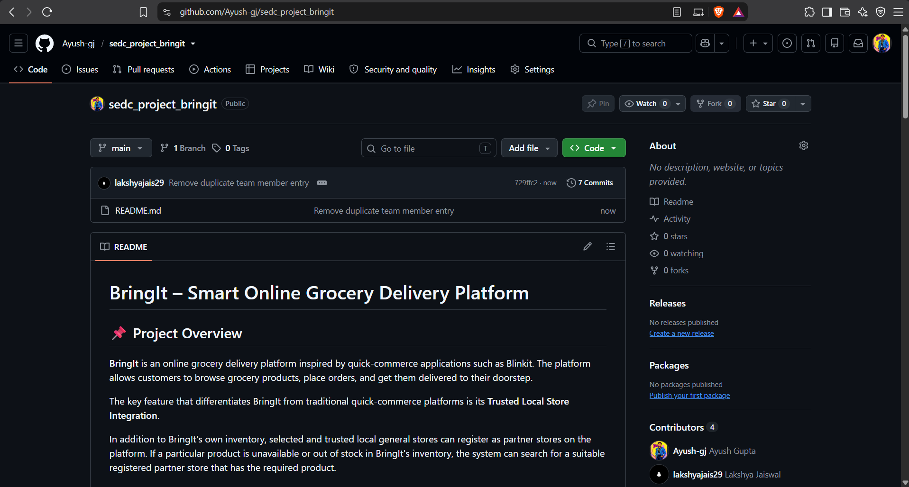
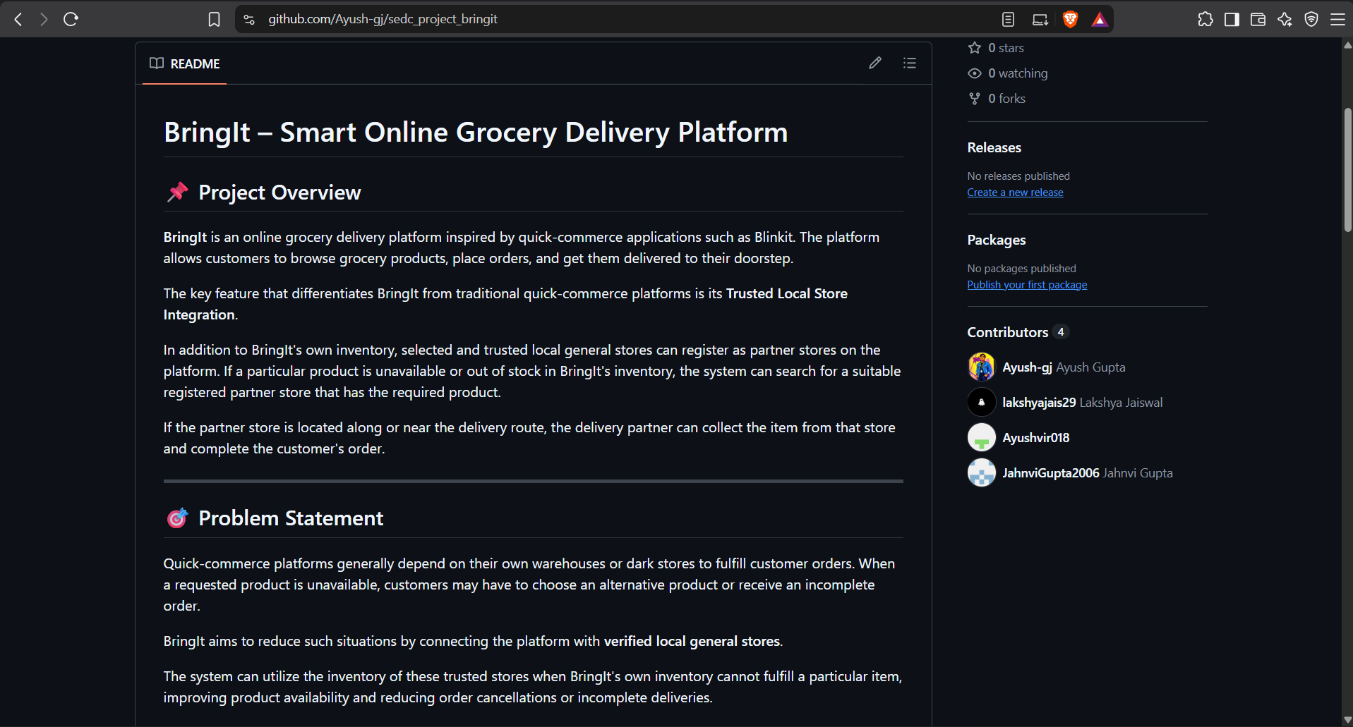

10. Current Project Status
The BringIt project is currently in the initial stage. The case study and its main idea have been identified, the project team has been formed, and the GitHub repository has been created.
At present, the repository contains the initial README.md file. Further project work, including requirements, design, development, testing, and documentation, will be carried out in the upcoming stages of the project.

11. Conclusion
BringIt aims to improve the online grocery delivery experience by combining the convenience of quick-commerce delivery with the availability of trusted local general stores. The proposed partner-store feature can help reduce the impact of out-of-stock products and improve order fulfillment.
This case study will be further developed during the semester using software engineering and design principles.

